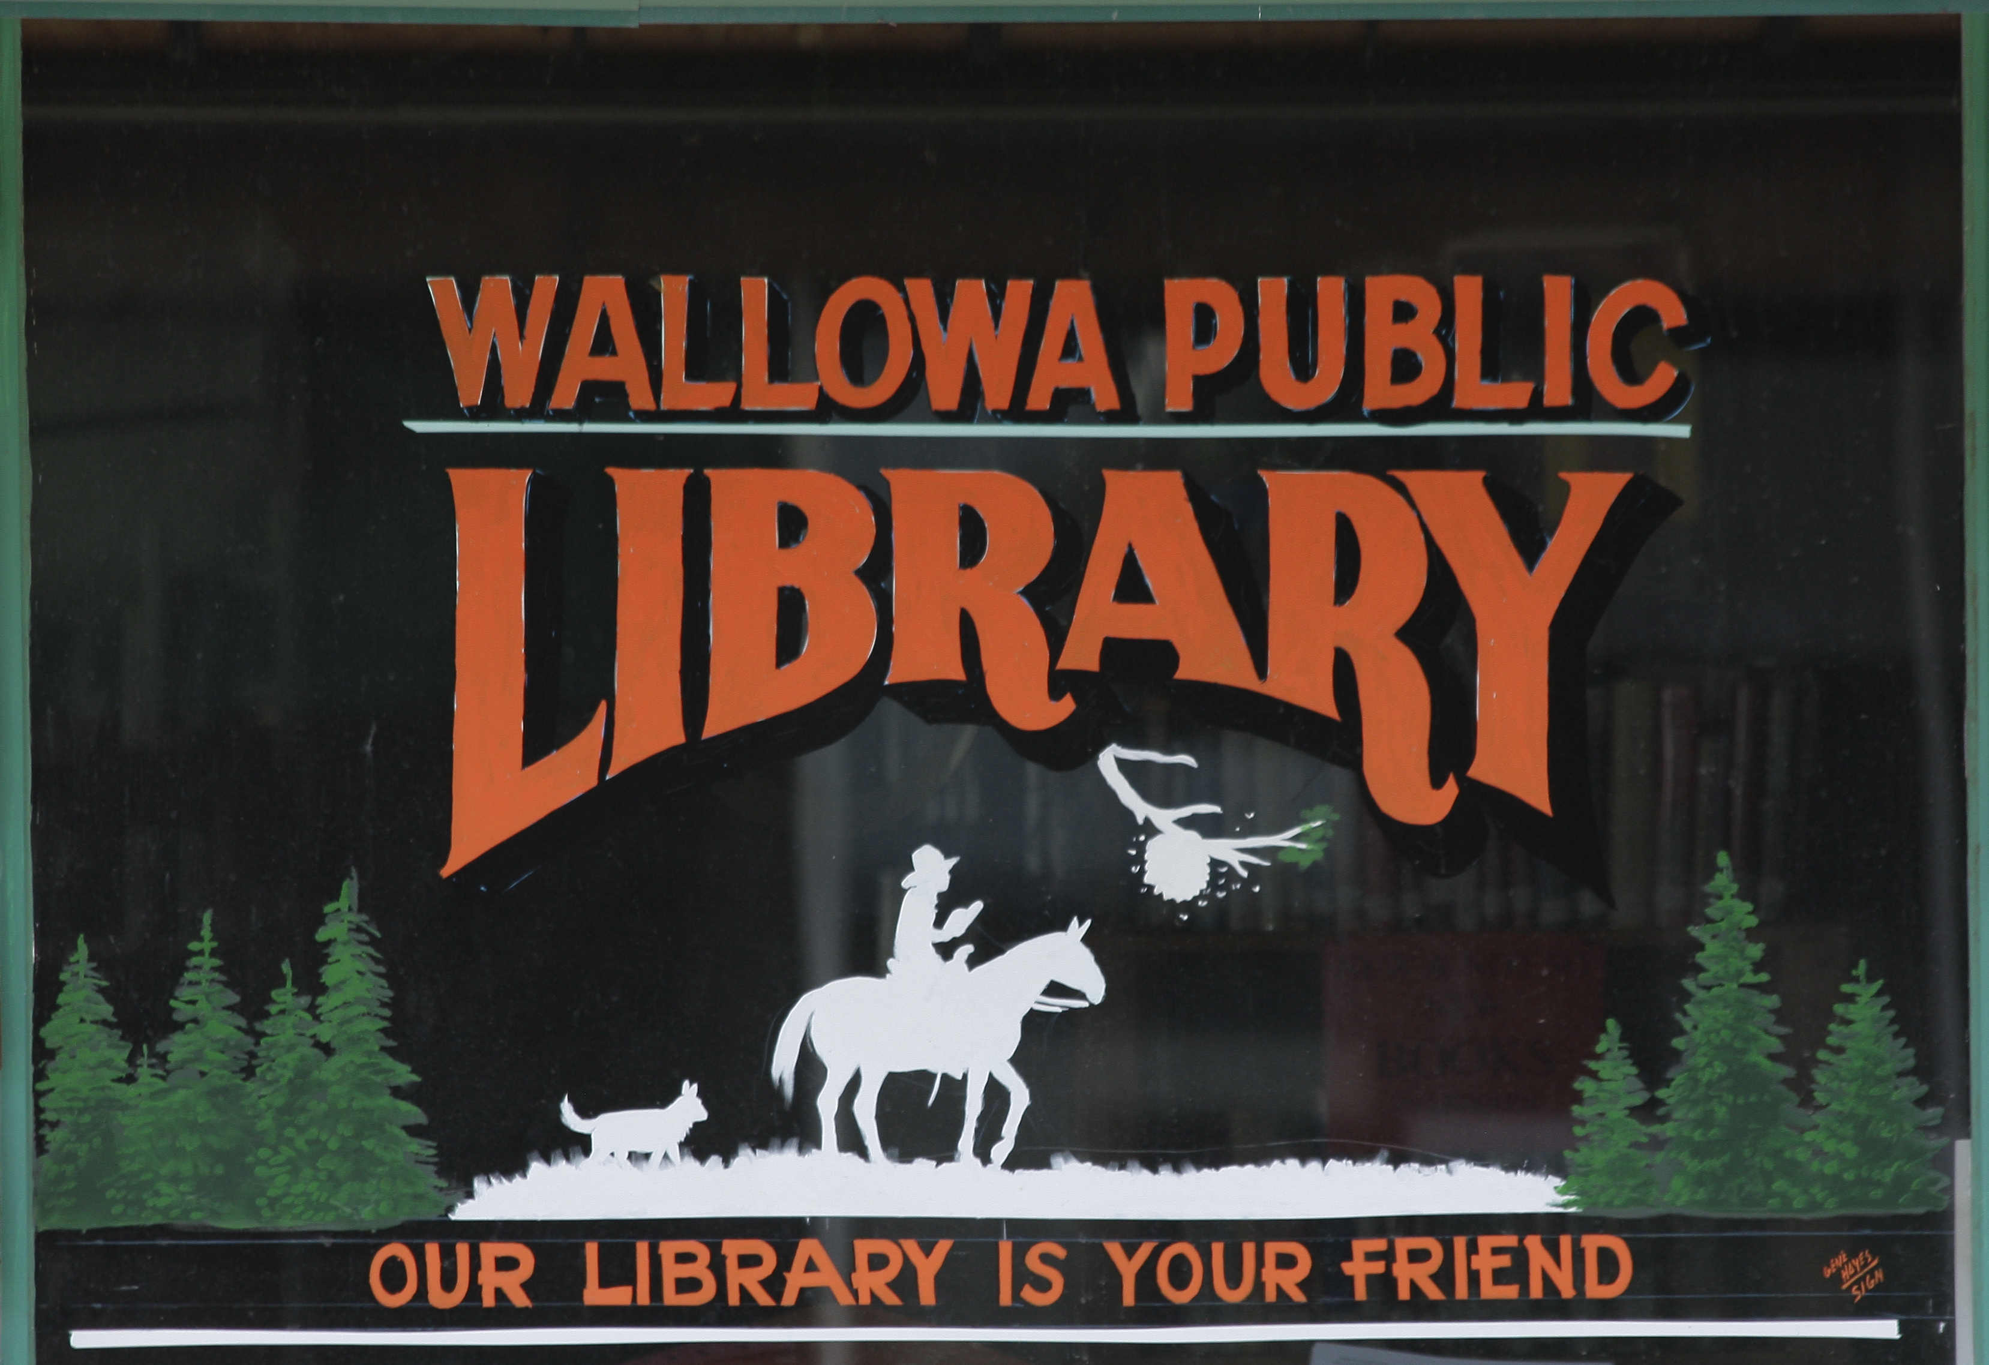

Collection Management and Withdrawal Policy for Library Resources

Selection and Acquisition:
Although the Wallowa Public Library Board is legally responsible for the operation of the library, the responsibility for selection of library materials is delegated to the library director.
Guidelines for Selection:
Educational, recreational, and informational value
Representation of varying points of view
Materials that complement the collection
Availability of material elsewhere
Funds and space on shelves
Materials that represent interest in the community
Materials by local authors
Materials of varying formats
Recommendations from patrons
Using resources such as local book stores, online services, and comparing prices as needed

Gifts and Donations
The Wallowa Public Library accepts gifts and donations. Monetary donations given directly to the Wallowa Public Library must be deposited with the city and added into the budget income. Non-monetary gifts or donations may be accepted or declined at the library director’s discretion.
Donated books will be assessed and possibly added to the collection as determined by the library director. Books that are in poor condition, damaged, dirty, or known to be of low value may be refused.
Other items such as artwork or furniture should be accepted only if space permits.
If a gift or book is given as a memorial, there are bookplates available that will acknowledge the donation. The donator will be made aware that the item donated is subject to weeding the same as all other books/items if damaged, has a long period without being checked out or information becomes outdated. If weeded, the front page with the bookplate will be removed and placed in a scrapbook that is currently being compiled by Friends of the Library. Donors will be supplied with a receipt of the tax-deductible donation upon request. Offers of donations of buildings/land should be coordinated with the Library Board of Directors and City Council.

Access
The Library Board considers reading, listening, and viewing to be individual, private matters. The Board believes that full, confidential, and unrestricted access to information is essential for patrons to exercise their constitutional rights. While anyone is free to select or reject materials for themselves or their own minor child(ren), the freedom of others to read or inquire will not be restricted. Only parents and guardians have the right and responsibility to guide and direct the reading, listening and viewing choices of their own minor child(ren). The Library does not stand in the place of parents (in loco parentis).

The Library collection will be organized, marked, and maintained to help people find the materials they want. Staff may not label, sequester, or alter materials because of controversy surrounding the author or the subject matter except when conducted in an education context.

Constitutional Protection
The Library Board considers all materials selected under this policy to be constitutionally protected under the First Amendment of the United States Constitution and the Oregon State Constitution.

Collection Review:
The Library Board recognizes the right of individuals to question the inclusion of materials in the Library collection. The Library will give serious consideration to the opinion of individuals who are full-year residents of, or own property, within the 97885 zip code.

Individuals questioning material in the Library collection may ask Library staff about such material. The staff Person in Charge of the Library at the time will hear and record these concerns, give the patron a copy of this policy, and refer the patron to the Library Director for further discussion or written response.

Individuals still questioning Library materials may submit their opinion in writing on a form provided by the Library. At this time, the Library Director will make contact with the State Library of Oregon staff for insight. The form will be sent to the Library Director who will consult with the Library Board to review the patron’s concerns and material in question and make a determination, or refer the matter to a Library committee formed by volunteers from the Library Board and Friends of the Library group. If referred, the committee formed will provide a recommendation to the Director as to whether the material was appropriately selected and made accessible under this policy.

The Director will review the recommendation, make the final decision, and reply to the individual in writing. The Director will keep the Library Board informed of all requests for reconsideration of library materials and their disposition. The Director will also report the challenge incident and outcome to the ALA Office of Intellectual Freedom.

Persons still wishing to express their concerns to the Library Board about materials in the collection will be heard during a regular meeting under the agenda item “Public Comment” or at another time designated by the Library Board for public expression. The Library Board, after receiving testimony from the public and from the Library Director, may decide whether the Library’s actions are in accordance with the Library policies or may refer the matter to a Materials Review Committee.

The Materials Review Committee will consist of three or five persons appointed ad hoc by the Library Board and will include the Library Director or a professional library staff member for the subject area of the item in question, the professional staff may be from another location and may join via phone or video call.

The review committee takes the following steps:
- Checks general acceptance of the material by reading reviews and consulting the recommended lists
- Reads, reviews, or listens to the material
- Determines the extent to which the material fits the selection policy
- Discusses materials confidentially
- Submits a written recommendation report to the Library Board.

If the Library’s actions are determined to be in conflict the Library policies, the Library Board will direct the Library Director on another course of action.

Withdrawal of Materials
The Library Board recognizes that withdrawing materials from the collection is an important part of maintaining the Library collection. Withdrawal of Library materials is vested in the Library Director who may authorize qualified staff or volunteers to assist. The withdrawal policy of the Library shall include the same factors as the selection policy and is not intended to sanction removal of Library materials based upon any controversy.

Collection Maintenance/Weeding Policy
Both print and non-print materials should be reviewed and evaluated at regular intervals to determine if they are to remain in the current collection. The librarian should consider space, subject, curriculum, and user needs when deciding how much and how often to weed. The librarian will decide how to best dispose of discarded materials.

Wallowa Public Library will function by allowing the Friends of the Wallowa Public Library access to weeded books for book sales.

Criteria for Weeding
Record of use – the item has not been circulated in 3 years
Currency – the subject matter is out of date, factually inaccurate, or no longer relevant to current times, illustrations are outmoded or perpetuate gender, racial, or cultural stereotypes.
Memorials – as above, remove the memorial plate and put in the memorial scrapbook to preserve name, consider including title page.
Technical Quality – non-print materials with poor visuals, faded or off color visuals, faulty of sound
Duplicate copies or duplicates no longer needed in collection
Physical condition – the item is torn, soiled, or worn, pages or parts are missing
Reliability – non-fiction item which contains factual information inconsistent with other, more recent, sources.
Short-lived topics – the item is faddish and no longer of interest
Dewey Decimal Balance – the item is unneeded to balance the collection

An item should NOT be discarded if
Local history – materials unique to Wallowa County
Works by local authors or illustrators
Special collections the library has collected

Policy Updated: November 13, 2023

_______________________________
Library Board Chair/date

________________________________
Library Director/date

